SOWIT Video Series – “Never Look a Gift Horse in the Mouth”
(Video link: www.edb.gov.hk/sowit_horse)

Lesson Plan
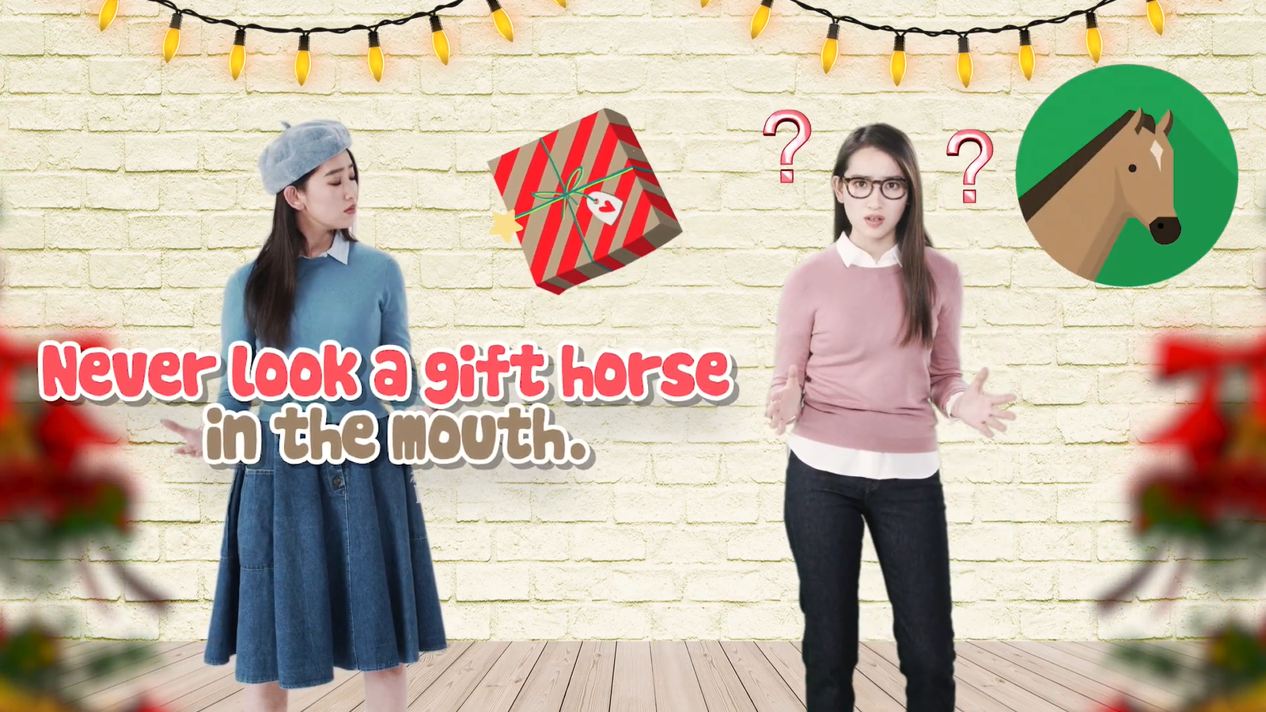

Suggested Levels
Upper Primary/Junior Secondary
Summary of the Learning Task
Students watch the SOWIT video “Never Look a Gift Horse in the Mouth”, which reminds us to be grateful when receiving a gift through the host’s personal experience and explanation of the ancient practice of evaluating the age of a horse by looking at its teeth. They are then guided to understand the meaning of the saying “Never look a gift horse in the mouth”, and the related positive values and attitudes (e.g. be grateful, cherish what we have, be positive), and give a presentation about a gift they have received before.
Learning Objectives
Content
- To understand the meaning of the saying “Never look a gift horse in the mouth.” through the personal experience and explanation of the host in the context of a video
Language
- To explore the different elements of the video (e.g. purpose, theme, facts, opinions)
- To indicate responses using the sentence pattern “When I …, I…”
- To compare and contrast how our attitude affects others’ feelings using the connective “however”
Values and Attitudes
- To cultivate positive values and attitudes (e.g. be grateful, cherish what we have, be positive)

Sharing Learning Intentions
- Introduce the objectives of the learning activities

Pre-viewing
Part A: Making Predictions about the Video
- Refer students to Activity Sheet: Part A.
- Draw students’ attention to the pictures below, which depict two scenes of the SOWIT video “Never Look a Gift Horse in the Mouth”:
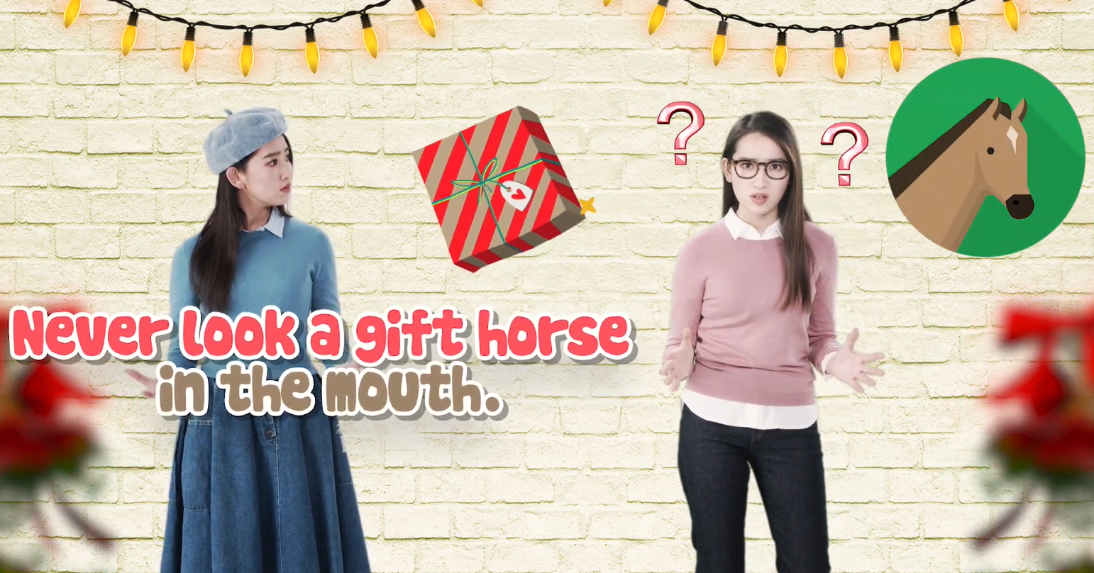
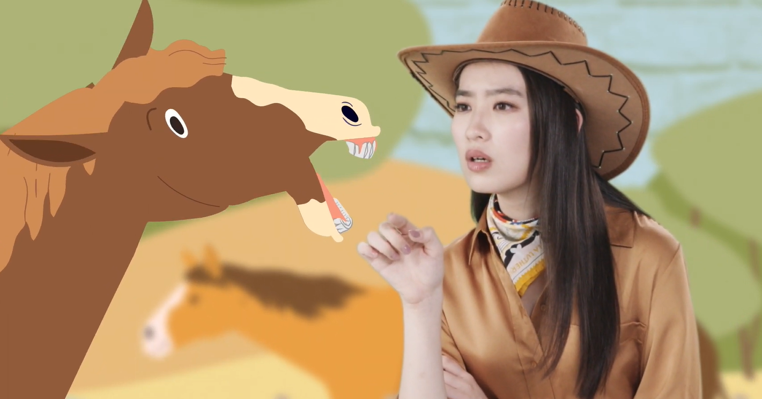
- Guide students to make predictions about the video by drawing their attention to the visual clues captured in the pictures (e.g. gift, question marks, horse, horse’s open mouth, horse breeder, facial expression and gestures of the host).
- Discuss with students their observations.

Viewing
Part B: Exploring the Different Elements of the Video
- Refer students to Activity Sheet: Part B.
- Introduce the different elements of the video (i.e. purpose, theme, facts, opinions) before playing the video and instruct students to note down some key points for each element while watching the video.
- Play the video “Never Look a Gift Horse in the Mouth”.
- Discuss with students the elements of the video.

Post-viewing
Part C: Comparison of Characters
- Refer students to Activity Sheet: Part C.
- Guide students to compare the responses and attitude of the characters (i.e. Ashley, Ashley’s friend and the horse breeder) in the video when they receive a gift using the sentence pattern “When I …, I…”.
- Play the video again whenever necessary.
- Discuss with students:
- what we should/should not do when receiving a gift; and
- how our response towards a gift affects the giver’s feelings.

Part D: Understanding the Saying of Wisdom
- Refer students to Activity Sheet: Part D.
- Revisit the meaning of the saying “Never look a gift horse in the mouth.” with students (i.e. we should be grateful when receiving a gift instead of being critical or refusing something good that is offered).
- Introduce the use of the connective “however” to make comparisons using the example given.
- Invite students to reflect on how their responses towards a gift or something good that is being offered affect the giver’s feeling by making a sentence using ‘however’.
- Highlight to students that it is important for us to be grateful for the good things offered and think from others’ perspective before giving a response.
- Ask students to give a presentation about a gift they have received before and reflect on what they can do if they receive a gift they do not like.

SOWIT Video Series – “Never Look a Gift Horse in the Mouth”
Activity Sheets
(Pre-viewing)
Part A: Making Predictions about the Video
- Study the pictures below, which depict two scenes of the SOWIT video “Never Look a Gift Horse in the Mouth”. What do you think the video is about? Write down your thoughts in Boxes (a) – (e).
- What do you think the gift was?

- Why did the girl on the right look so confused?

- What was the job of the girl?

- What do you think the saying “Never look a gift horse in the mouth.” means?

- Which part of the horse was the girl looking at? Why did she do that?

(Viewing)

Part B: Exploring the Different Elements of the Video
- Watch the video and complete the table below:
Theme  (What is the subject/main idea of the video?) | - Put a tick () in the correct box.  Friendship  Horse breeding  Gratitude
Purpose  (What does the video aim to achieve?) | - Fill in the blanks.  i) To introduce the saying of wisdom “__________________  ________________________________________________”.  ii) To remind us that we should be __________ when receiving a __________ instead of being _______________ of it.
Fact  (Something that is known or proved to be true) | - Are the following facts or opinions? Put the letters (A-E) in the correct box.  - The host, Ashley, always said “Thank you!” when receiving a present.  - Ashley’s friend always asked a lot of questions when she received a gift.  - We should consider the giver’s feelings when receiving a gift.  - Ancient horse breeders evaluated the age of a horse by looking at its teeth.  - Both the giver and the recipient will feel happy if the recipient is grateful when receiving a gift.  Opinions  Facts
Opinion

(A view or a judgement)

(Post-viewing)
Part C: Comparison of Characters
- How did the characters in the video (i.e. Ashley, Ashley’s friend and the horse breeder) respond when they received a gift? What was their attitude?
Ashley  (a) “When I receive a gift, I ____________  _______________________________________”  (b) I think she is a/an __________________ person. | Ashley’s friend  (c) “When I receive a gift, I ____________  _______________________________________”  (d) I think she is a/an __________________ person. | The horse breeder  (e)“When I receive a gift horse, I ________  _______________________________________”  (f) I think she is a/an __________________ person.

- Which character’s response would you like best if you were the giver of the gift? Why?
________________________________________________________________________________________________________

- What should we do/not do when receiving a gift?
________________________________________________________________________________________________________
Part D: Understanding the Saying of Wisdom

- What is the message conveyed by the video?

_____________________________________________________________________

_____________________________________________________________________

- What is the meaning of the saying “Never look a gift horse in the mouth”?

_____________________________________________________________________

_____________________________________________________________________

- In the video, Ashley’s friend criticised every single present Ashley gave her and this upset Ashley. Let’s think about how our response towards the gifts and something good that is being offered may affect others’ feelings. Use the connective “however” to show the positive and negative impacts of our responses. Share your ideas with your classmates.

Example: Sometimes I refuse to drink the soup my mother makes, which lets her down. However, when I empty the bowl and tell her how delicious the soup is, she is filled with joy.
The gift/Something good that is being offered:
______________________________________________________________

How the giver may feel:

________________________
An appropriate response/
Positive attitude:

_________________________________________________________________________________
An inappropriate response/ Negative attitude:

__________________________________________
How the giver may feel:

____________________________
Your experience: _____________________________________________________________

___________________________________________________________________________.

- Have you ever received a gift that you do not like? What was your attitude towards the gift? Give a presentation about a gift you have received before and share what we can do if we receive a gift we do not like. You may include the following details in your presentation:

SOWIT Video Series – “Never Look a Gift Horse in the Mouth”
Activity Sheets (Suggested Answers)

Part A: Making Predictions about the Video
1(a) | A horse (Accept any reasonable answers.)
1(b) | She received a horse as a gift. (Accept any reasonable answers.)
1(c) | A horse breeder/cowgirl (Accept any reasonable answers.)
1(d) | She was looking at the horse’s teeth/tongue/mouth to check its age/health.  (Accept any reasonable answers.)
1(e) | Accept any reasonable answers.

Part B: Exploring the Different Elements of the Video
1(a) | Gratitude
1(b) | i) To introduce the saying of wisdom “Never look a gift horse in the mouth”.  ii) To remind us that we should be grateful when receiving a gift/present instead of being critical of it.
1(c) | Facts: A, B & D  Opinions: C & E

Part C: Comparison of Characters
1(a) | When I receive a gift, I say “Thank you!” (Accept any reasonable answers.)
1(b) | grateful (Accept any reasonable answers.)
1(c) | When I receive a gift, I ask many questions to criticise the gift. (Accept any reasonable answers.)
1(d) | critical/ungrateful/inconsiderate (Accept any reasonable answers.)
1(e) | When I receive a gift horse, I look at its teeth to evaluate its age. (Accept any reasonable answers.)
1(f) | critical/ungrateful/inconsiderate (Accept any reasonable answers.)
2. | Accept any reasonable answers.
3. | Accept any reasonable answers.

Part D: Understanding the Saying of Wisdom
- We should be grateful when receiving a gift instead of being critical or refusing something good that is offered. (Accept any reasonable answers.)
- The saying refers to the practice of evaluating the age of a horse by looking at its teeth. It means we should be grateful when receiving a gift. (Accept any reasonable answers.)
- Accept any reasonable answers.

